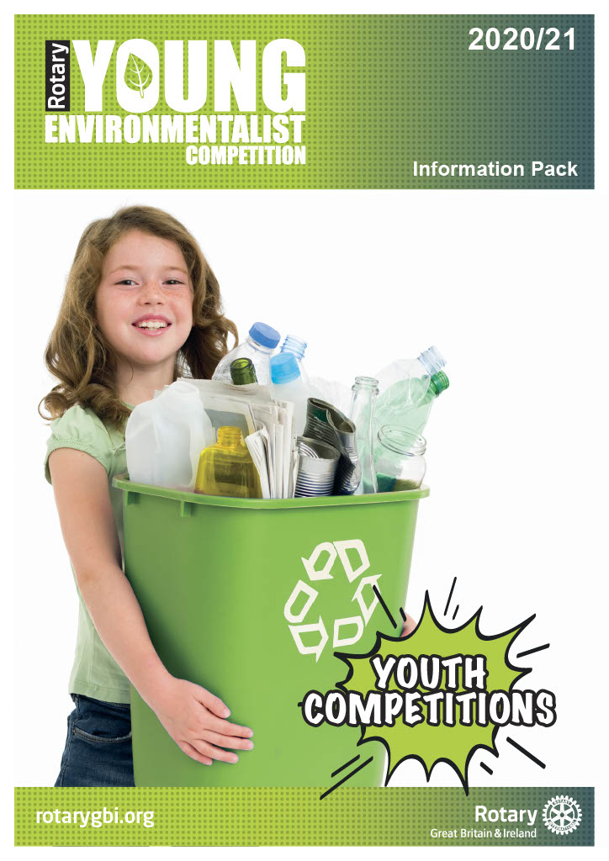

Information Pack for 2020 – 2021

Content:

Introduction Page 2

Aims and Objectives Page 2

Who Can Take Part? Page 2

The Three Stages of the Competition Page 3
- Local Heats
- District Finals
- National Final

Competition Guidelines Page 3 - 5
- Task
- Outcomes
- Presentation
- Judging Criteria
- Prizes

How To Enter Page 5

Rotary Youth Competitions Page 5

Working with Children Page 5

Information Pack for 2020 – 2021

Introduction

The Rotary Young Environmentalist Competition is a new competition organised and promoted by Rotary International in Great Britain and Ireland (Rotary GB&I).

There are three stages to the competition, each designed to support and encourage the development of environmental skills. Some stages may have more than one round.

Aims and Objectives

The competition aims to encourage young people to:

- interact with the environment
- address serious environmental issues
- develop and explore solutions to the issues
- explore, investigate, research and undertake an environmental sustainability project

Who can take part?

The competition is open to all schools and college communities and those who are home educated, along with any other young peoples’ community organisations, for example, community RotaKids, community Interact, Scout Groups, Girl Guides.

There are three age groups:

Junior 7 to 10 years old
Intermediate 11 to 13 years old
Senior 14 to 17 years old

Entrants must not exceed the upper age parameter for each group on 31 August 2020.

With the age qualifying date of 31st August 2020, it should be noted that some junior entrants may be 11, intermediate entrants may be 14 and some senior entrants may be 18 at the time of some or all the stage competitions i.e. a competitor who may be 17 on 31st August but turns 18 on 1st September is allowed to enter. Competitors must include their age on the application form.

Students should enter the competition organised by the local Rotary club through their respective group, as detailed above.

Competitors, schools, colleges and youth organisations may participate in competitions organised by a Rotary club or district outside of their geographical boundary but may compete in only one club/district event.

There are two categories in the competition per indicated age group
- Individual entry open to all categories, Junior, Intermediate and Senior.
- Group entry (maximum of four participants) open to Junior and Intermediate categories only

The Three Stages of the Competition

Local Heats
These are organised by local Rotary clubs between September and December. The winners of each age group, per category are entered into a district competition.

Local Rotary Clubs can be found by using the club finder facility in the top left-hand corner of the Home Page of the Rotary International in Great Britain and Ireland website www.rotarygbi.org.

District Competitions
These are organised by Rotary between January and February. The winners of each age group per category are entered into the national final.

National Final
This is organised by Rotary. One entry per age group, per category from each district may be submitted by Monday 29th March 2021 to the Rotary Support Centre. Where possible entries to be submitted electronically to the Rotary Support Centre. Example of exceptions are 3D models

IMPORTANT RESTRICTIONS TO NOTE: Please note that entries and supporting information sent electronically MUST NOT EXCEED 15Mb per email sent. Emails over this limit will not be received at the Support Centre. Alternative options are to send the nomination and supporting information across several emails or contact Andy Smith, Rotary CDS Team, to organise a file transfer facility

The dates for local heats and district competitions will be determined locally. Entrants should check dates with their local Rotary club in the first instance.

Competition Guidelines

Purpose
To engage young people to interact with the environment, address serious issues, and develop and explore solutions to the problems.

Objectives
To encourage young people to explore, investigate, research and undertake an environmental sustainability project on the theme of ‘Climate Change/Carbon Reduction’. The two are interlinked and those entering may focus on one or the other or both
To select a topic with this theme. Topics could include recycling, plastic pollution, litter abatement, micro-plastic contamination, reduction in the need for, and reuse of materials, issues where other criteria are paramount such as sterilisation needs in medical applications, etc.
The project undertaken should raise awareness to a particular problem within the given topic area and inspire action to respond to the growing awareness of the problem.
For instance, actions in response to the growing awareness of plastic pollution in the environment would come from understanding the properties of plastics and why they are so widely used, and in the way in which they create problems for wildlife and humans. The response would also include ways to control the problem by exploring solutions.
Task
Select a topic and undertake some research and exploration into the current magnitude of the problem. They may work on projects on their own or as part of a group of not more than 4 people.
Decide and develop their own ideas while undertaking the project and offering solutions.
The project could be approached from different angles and perspectives.
Projects could also seek methods by which existing solutions can be implemented. Possible projects could include one or more topics such as:
- Recycling isn’t a panacea (identify ways to reduce or reuse)
- Reducing the amount of raw material consumed
- Developing new up-cycled products from recyclates
- Turning waste into useful objects
- Tackling the problems associated with Fast Fashion
- Exploring innovative ways of using plastic
- Benchmarking the magnitude of problem in local area (e.g. how much waste is generated in the home, school, or community)
- Analysing secondary statistical data on waste from Official Publications
- Obtaining photographic evidence of litter in the environment.

These are just some ideas; students are encouraged to develop their own projects within the general theme of Waste Minimisation.

Students in the older age group are encouraged to explore and develop new concepts other than those regularly reported in the popular press.

Outcomes
Young people should engage with the Environment and identify current issues.

Projects should be eye catching, present a balanced viewpoint exhibiting understanding of the environmental problem, and showcase a solution or suggest an innovative new idea for solving the environmental issue.

Presentation
The project is to be presented in the student’s or group’s chosen format.

These could include:
- Written and illustrated submissions
- Photographic or artistic presentations
- Audio or video reports
- A tangible product such as an App for smart phone
- Interactive conversations or creative movement

Written reports should be well illustrated and be no more than 1000 words long.

Poster displays should be A3 or A4 size in colour or black and white with images and text.

Judging Criteria
Evidence and Research

The project must demonstrate that exploration and some research has been undertaken.

Effectiveness

The aims of the project must clearly be stated, and outcomes must be capable of assessment and demonstrate sustainability.

Innovative

New concepts and ideas are valuable and will be recognized.

Adaptability

The project should be capable of replication by others based on the information provided.

Beneficiaries

What is the benefit of the project? Enumerate the benefit to the Community. Is it potentially cost effective in the long term?

Lessons Learnt

What have been the problems? What has been discovered are the solutions adequate? How can it be improved?

Presentation

How much information has been given? Is it imaginative and eye catching? What is the impact? Is it easy to follow and understand? What is the quality of the content?

Evidence of Teamwork

If undertaken in a group, what is the evidence of teamwork?

Prizes
At all stages of the competition, competitors will receive a certificate of participation.

How to enter

To enter a local heat, contact your local Rotary club which can be found by visiting www.rotarygbi.org. In case of difficulty, contact the Rotary Youth Competition Co-Ordinator, for assistance Keith Tovey young-enviromentalist@rotarygbi.org

Entrants require to complete an entry form and submit it along with their entries, to the stage organiser by the time specified.

Important Notice: Please note that photographs and videos of people under 18 years old must be accompanied by written permission from the parent, guardian or carer of the person(s) photographed. Please attach individual Rotary GB&I ‘Form B: Consent form for the use of photographs, film or video recordings of children or vulnerable adults’

Rotary Youth Competitions

This Young Environmentalist Competition is one of eleven competitions for young people organised by Rotary International in Britain and Ireland. The others are: Young Artist, Young Chef, Youth Debate, Young Filmmaker, Young Musician, Young Photographer, Young Scientist, Young Writer, Young Citizen Awards and the Technology Tournaments. To find out more about these competitions and other opportunities please contact your local Rotary club in the first instance.

Working with Children

Rotary International in Great Britain and Ireland has adopted this statement of policy in working with children, vulnerable adults and those with disability:

The needs and rights of the child, the elderly, the vulnerable and those with disability take priority. It is the duty of every Rotarian to safeguard to the best of their ability, the welfare of and prevent the physical, sexual or emotional abuse and neglect of all children, the elderly, persons with disability or otherwise vulnerable persons with whom they come into contact during their Rotarian duties.

