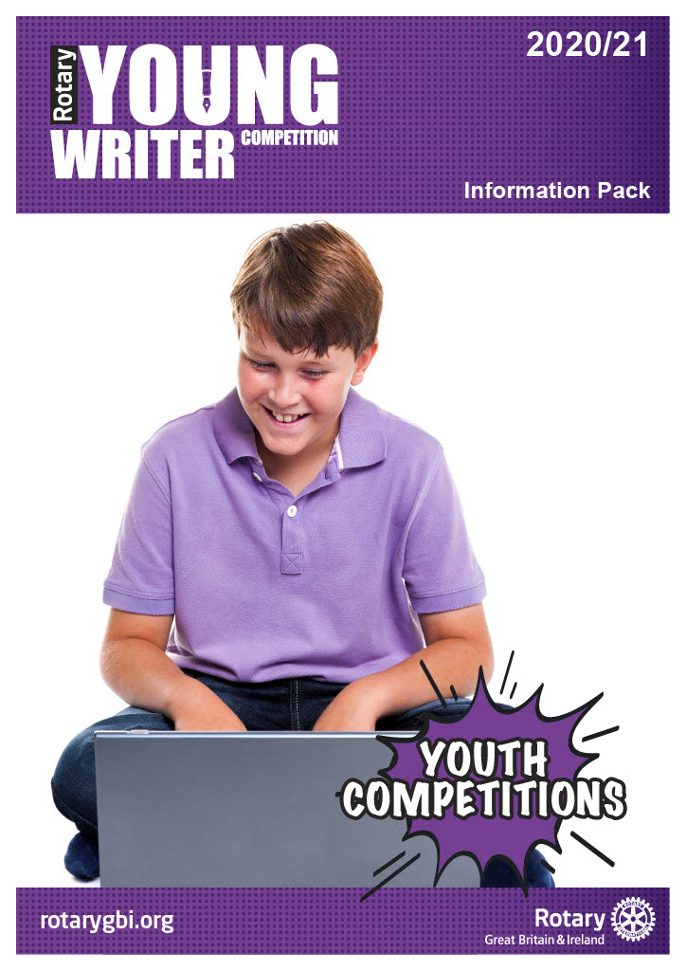

Information Pack for 2020 – 2021

Content

Introduction Page 3

Aims and Objectives Page 3

Who Can Take Part? Page 3

The Three Stages of the Competition Page 4
- Local Heats
- District Finals
- National Final

Competition Guidelines Page 4 - 5
- Task
- Judges
- Judging Criteria
- Prizes

How to Enter Page 5

Youth Competitions Page 5

Working with Children Page 5

Information Pack for 2020 – 2021

THEME – ‘MY HAPPIEST DAY’

Introduction

This National Young Writer Competition is a well-established and successful competition promoted by Rotary International in Britain and Ireland (Rotaty GB&I).

It is a three-stage competition designed to support and encourage development of writing skills.

Aims

This competition aims to encourage young people to:

- use their writing skills
- write with imagination and creativity

Who can take part?
The competition is open to all schools and college communities including those that are home educated and any other young peoples’ community organisations, for example, community RotaKids, community Interact, Scout Groups, Girl Guides.

The three age groups are:

Junior 7 to 10 years old
Intermediate 11 to 13 years old
Senior 14 to 17 years old

Entrants must not be above the age parameters for each group on 31 August 2020.

With the age qualifying date of 31st August 2020, it should be noted that some junior entrants may be 11, intermediate entrants may be 14 and some senior entrants may be 18 at the time of some or all the stage competitions i.e. a competitor who may be 17 on 31st August but turns 18 on 1st September is permitted to enter. Competitors must include their age on the 31st August 2020 on the entry form.

For entrants with motor control difficulties, an amanuensis may be used to record the entrant’s work to paper.

Students should enter the competition organised by the local Rotary club through their respective group as detailed above.

Competitors, schools, colleges, and organisations may participate in a club or district competition that is outside of their geographical boundary but may compete in only one club or district competition.

The Three Stages of the Competition

Local Heats
Organised by local Rotary clubs. Age group winners of local heats are entered into a district competition.

Local Rotary clubs may be found by using the club finder facility in the dialogue box “Find My Nearest Club” at the top left-hand corner of the Home Page of the Rotary International in Great Britain and Ireland website www.rotarygbi.org/

District Finals
Organised by Rotary districts between January and February. The winners of each are entered into the national final.

National Final
Organised by Rotary. One entry per age group per district, may be submitted by entries to national final, via electronic format by Monday, 29th March 2021 to the Rotary Support Centre. The co-ordinator Bob Tomlinson, can be contacted at young-writer@rotarygbi.org

IMPORTANT RESTRICTIONS TO NOTE: Please note that entries and supporting information sent electronically MUST NOT EXCEED 15Mb per email sent. Emails over this limit will not be received at the Support Centre. Alternative options are to send the nomination and supporting information across several emails or contact Andy Smith, Rotary CDS Team, to organise a file transfer facility.
The dates for Local Heats and district competitions will be determined locally. Interested parties should check dates with their local Rotary club.

Competition Guidelines

Task
To produce a written or typed story in prose entitled, ‘My Happiest Day’. The written entry could be fiction or non-fiction, prose, or a poem, as long as the piece relates to the theme.
Up to maximum of 550 words for prose entries.

Up to a maximum of 40 lines for poetry entries.

No pictures/drawings to be part of the entry.

All entries to be legible. Can be written or typed

Entries should be sent to the Stage organiser by the closing date.

Entries may not be returned unless specifically requested.

Judges
Judges with appropriate skills, appointed by Rotary, will apply the judging criteria below.

Judging Criteria
Judges will consider imagination relative to the subject; the ability to engage interest and to be consistent in the power of argument.

The judges will not enter into any discussion or correspondence regarding their decision; their decision will be final and not subject to any appeal.

Prizes
At all stages of the competition, competitors will receive a certificate of participation.

At the National Final, the winners will receive a vocational experience such as working in a newspaper or publishing environment with a professional practitioner.

How to enter

To enter a local heat, interested parties should contact their local Rotary club. In case of difficulty interested parties should contact the Rotary Youth Competition Co-Ordinator, Bob Tomlinson young-writer@rotarygbi.org for assistance.

Entrants are required to complete an entry form, available from your local Rotary club, and submit it with their text, to the stage organiser at the time specified by the stage organiser.

Youth Competitions

The Young Writer competition is one of a number of competitions for young people organised by Rotary International in Great Britain and Ireland. Among the others are Young Artist, Young Chef, Youth Debate, Young Environmentalist, Young Filmmaker, Young Musician, Young Photographer, Young Citizens Awards and the Technology Tournaments.

To find out more about these competitions and other opportunities for young people, please contact your local Rotary Club or visit www.rotarygbi.org.

Working with Children

Rotary International in Great Britain and Ireland has adopted this statement of policy in working with children, the vulnerable and those with disability.
The needs and rights of the child, the elderly, the vulnerable and those with disability take priority. It is the duty of every Rotarian to safeguard to the best of their ability, the welfare of and prevent the physical, sexual or emotional abuse and neglect of all children, the elderly, persons with disability or otherwise vulnerable persons with whom they come into contact during their Rotarian duties.

